

**OS LAB**

**(CSL-408)**

**Final Lab Assignment**

|  |  |
| --- | --- |
| **Submitted To:**  Ms. Sunita Sharma | **Submitted By:**  Vrishav Garg |

12111051

Branch: CSE

Semester: IV

Session: 2021-25

**Index**

|  |  |  |
| --- | --- | --- |
| **S.No.** | **Practical** | **Page no.** |
| 1. | Easy Leave Management System | 3-8 |
| 2. | Course Management System | 10- |
|  |  |  |

**ASSIGNMENT-1**

**AIM**

**Easy Leave:** This project is aimed at developing a web-based Leave Management Tool, which is of importance to either an organization or a college.

**User Stories**

* As an employee, I want to be able to log in to the leave application system with my username and password so that I can access my leave balance and submit leave requests.
* As an employee, I want to see my current leave balance displayed prominently on the dashboard so that I can easily check how many leave days I have available.
* As an employee, I want to be able to submit a leave request by specifying the type of leave (e.g., vacation, sick leave), the dates, and a brief reason for my absence.
* As an employee, I want to receive a confirmation email after submitting a leave request so that I know it has been received and is being processed.
* As a manager, I want to receive notifications when my team members submit leave requests so that I can review and approve or deny them in a timely manner.
* As a manager, I want to be able to view a calendar that shows the leave schedule for my team so that I can plan work assignments accordingly.
* As an employee, I want to be able to view the status of my leave requests (e.g., pending, approved, denied) at any time.
* As an administrator, I want the system to generate reports on leave usage and balances for payroll and auditing purposes.
* As a manager, I want the system to provide me with an overview of my team's overall leave usage and balances so that I can effectively manage workload distribution.

**Functional Requirements**

* User Authentication and Authorization:

The system must provide secure user authentication, including the ability to reset passwords. Users must have appropriate roles and permissions (e.g., employee, manager, HR administrator).

* Leave Request Submission:

Employees should be able to submit leave requests specifying leave type, dates, and a reason.

* Leave Approval Workflow:

Managers should receive notifications and be able to approve or deny leave requests.

* Leave Balances and Deductions:

Leave balances should be updated automatically upon approval or denial of leave requests. The system should prevent employees from requesting more leave than their available balance.

* Leave Tracking and Reporting:

Employees and administrators should be able to track the status of leave requests. The system should generate reports on leave usage and balances.

* Calendar Integration:

The system should integrate with company calendars and email systems, displaying approved leave on work calendars and sending notifications.

* Mobile Accessibility:

The system should be accessible via a mobile app, allowing employees to submit and track leave requests on the go.

* Reminders:

Employees should receive reminders about upcoming leave days to help them plan their work schedules.

* Leave Modification and Cancellation:

Employees should have the ability to modify or cancel pending leave requests before approval.

**Non-Functional Requirements:**

* Security:

The system must ensure data security and privacy, including encryption of sensitive information. Access to sensitive data should be protected through role-based access control.

* Performance:

The system should have low response times, even during peak usage periods. It should be able to handle a large number of simultaneous users.

* Reliability:

The system should be available and reliable, with minimal downtime for maintenance.

* Scalability:

The system should be able to scale to accommodate the growing number of users and leave requests.

* Usability:

The user interface should be intuitive, easy to use, and accessible on multiple devices (desktop, mobile).

* Compliance:

The system should comply with relevant labor laws and company policies.

* Notifications:

Notifications, including emails and mobile app alerts, should be timely and reliable.

* Integration:

The system should integrate with existing HR and payroll systems for data synchronization.

* Audit Trail:

The system should maintain an audit trail to track all changes and actions related to leave requests.

* Backup and Recovery:

Regular data backups and a robust recovery mechanism should be in place to prevent data loss.

**Use Case-diagram:**

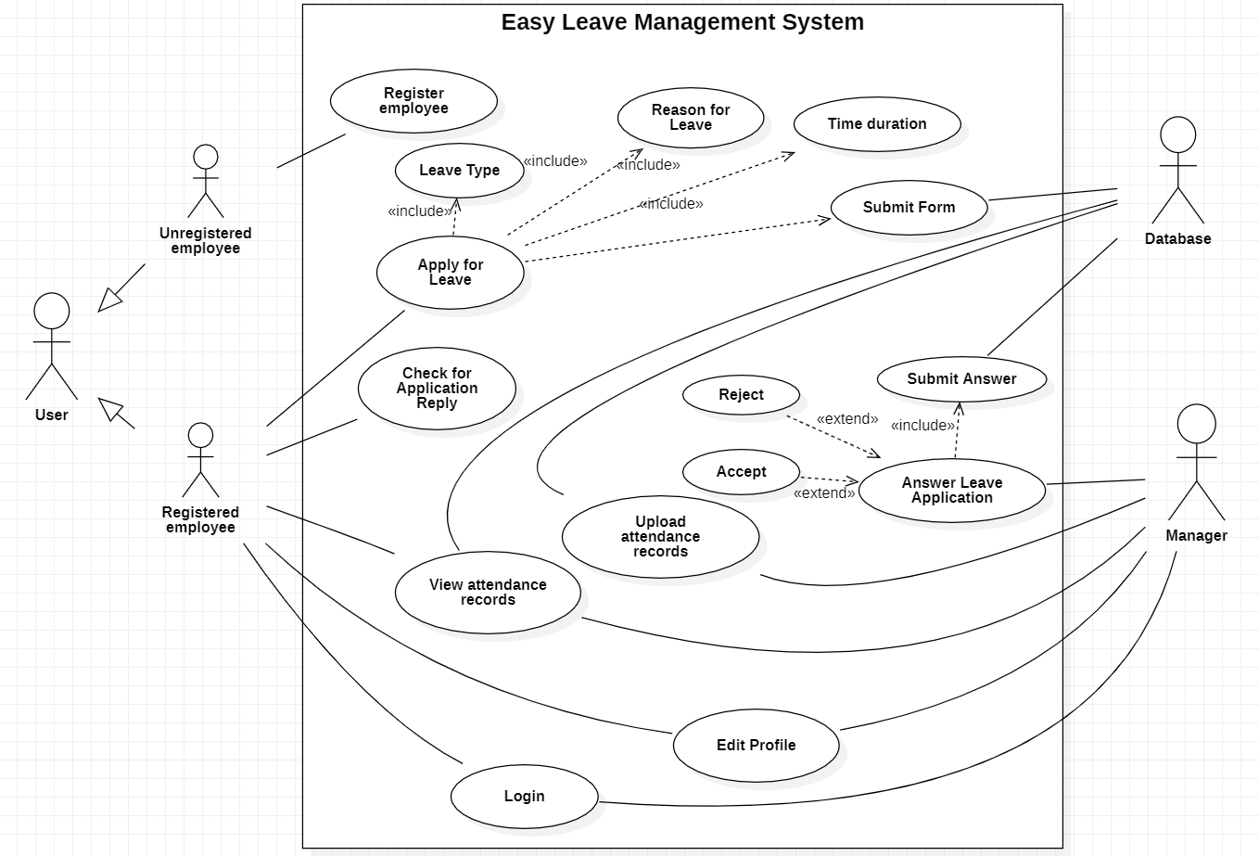

**Activity Diagram:**

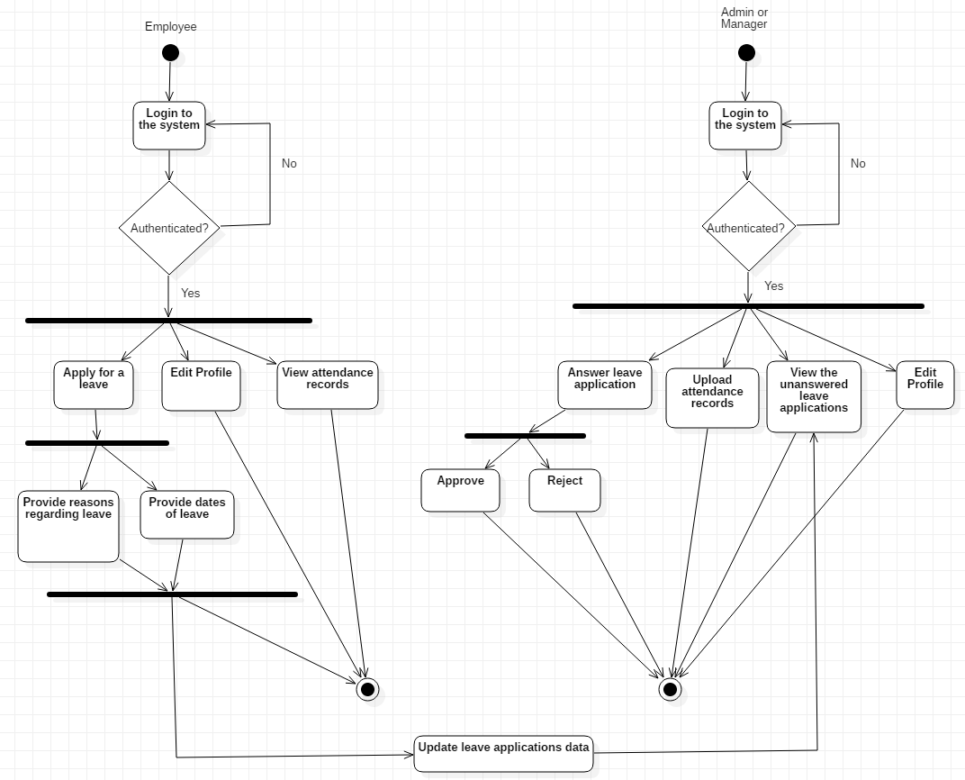

**Class Diagram:**

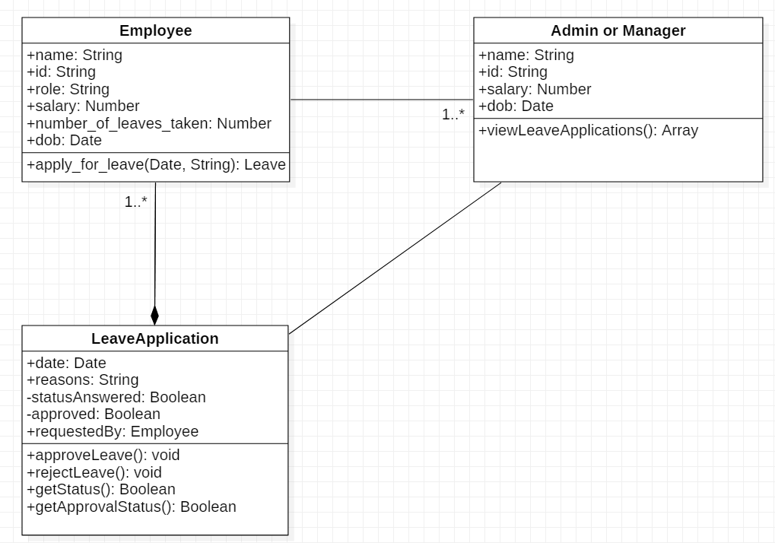

**Sequence diagram:**

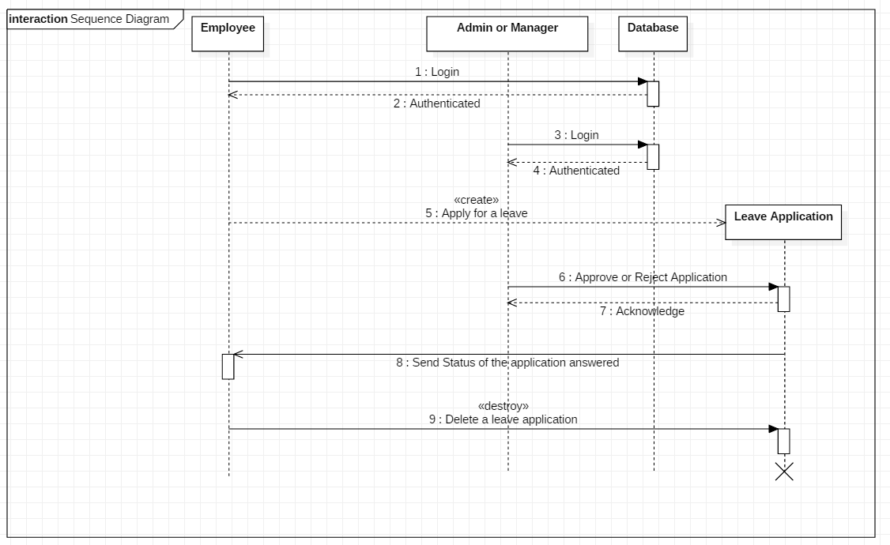

**Assignment-2**

**AIM:**

**Course:** This project is aimed at developing a web-based Course Management Tool, which is to provide an efficient and user-friendly platform for educational institutions to manage their courses, student enrolments, and resources.

**User Stories**

* As a student, I want to be able to browse and enroll in courses.
* As a student, I want to access course materials and receive updates from my instructors.
* As a student, I want to track my progress and view my grades.
* As a teacher, I want to be able to manage course materials, assignments, and grades for my students.
* As a teacher, I want to communicate with my students and provide feedback on their assignments.
* As a teacher, I want to schedule and manage class sessions, including virtual meetings.
* As an administrator, I want to be able to create, update, and delete courses.
* As an administrator, I want to generate reports on course enrollment and student progress.
* As an administrator, I want to manage user accounts, roles, and permissions.

**Functional Requirements**

* User Authentication and Authorization:

Users should be able to register, log in, and have different roles (admin, teacher, student) with appropriate permissions.

* Course Management:

Create, update, and delete courses. Assign instructors to courses.

* User Profile Management:

Users should be able to update their profiles, including contact information.

* Course Materials:

Instructors should be able to upload and manage course materials, including documents, videos, and links.

* Enrollments:

Students should be able to enroll in courses, and instructors should be able to view and manage course rosters.

* Communication:

Implement messaging and notification features for communication between students and instructors.

* Assignments and Grading:

Instructors should be able to create assignments, and students should submit assignments. Instructors can grade and provide feedback.

* Scheduling:

Allow the scheduling of class sessions, including in-person and virtual meetings, with calendar integration.

* Reporting:

Provide reporting capabilities for administrators to monitor course enrollment, student progress, and system usage.

**Non-Functional Requirements:**

* Security:

Implement data security measures to protect user data and ensure compliance with data privacy regulations.

* Performance:

The system should be able to handle a large number of users and course data efficiently, with minimal latency.

* Reliability:

Ensure system uptime and availability with minimal downtime for maintenance.

* Scalability:

The system should be scalable to accommodate growth in the number of users and courses.

* Usability:

The system should be user-friendly, with an intuitive interface and responsive design for various devices.

* Compliance:

Comply with relevant regulations and standards, especially regarding data protection and privacy.

* Notifications:

Notifications, including emails and mobile app alerts, should be timely and reliable.

* Integration:

Support integration with external systems, such as a Learning Management System (LMS) or student information system.

* Accessibility:

The system should be accessible to users with disabilities, following accessibility standards.

* Backup and Recovery:

Regularly back up data and have a plan for data recovery in case of system failures.

**Use Case-diagram:**

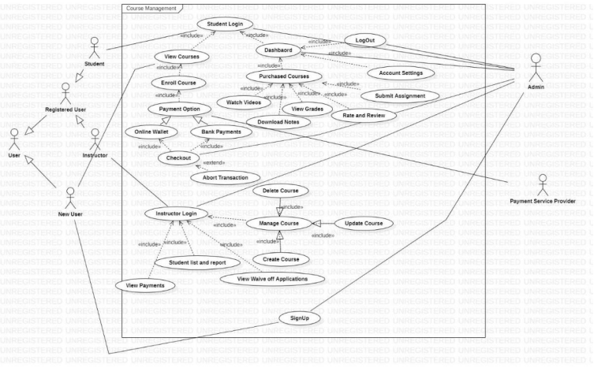

**Activity Diagram:**

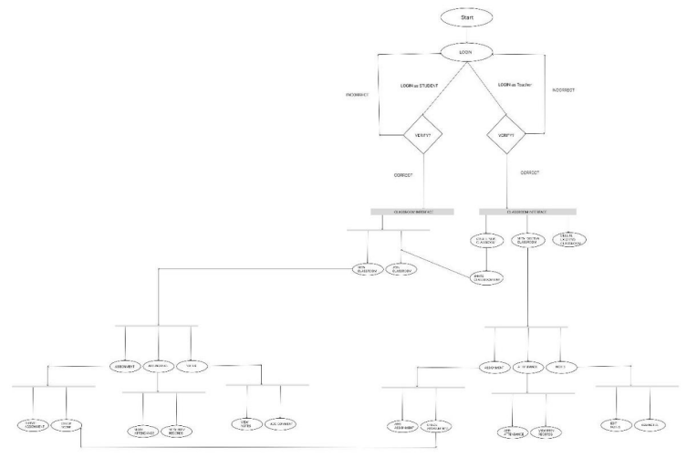

**Class Diagram:**

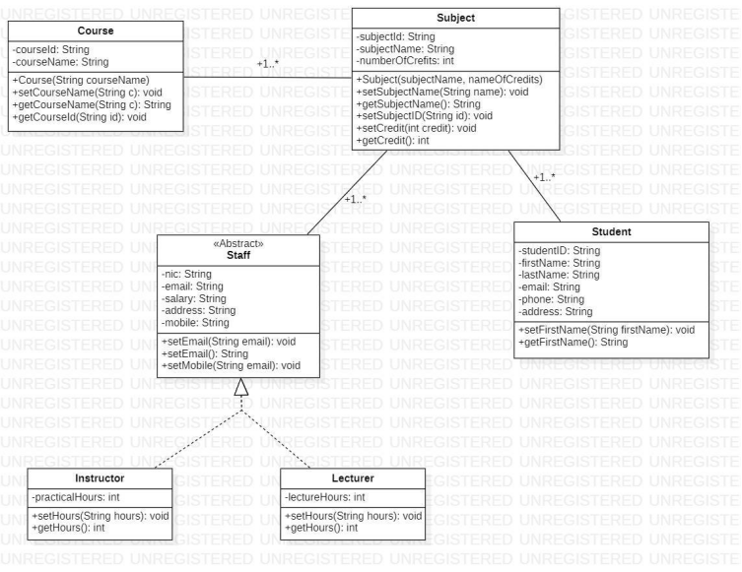

**Sequence diagram:**

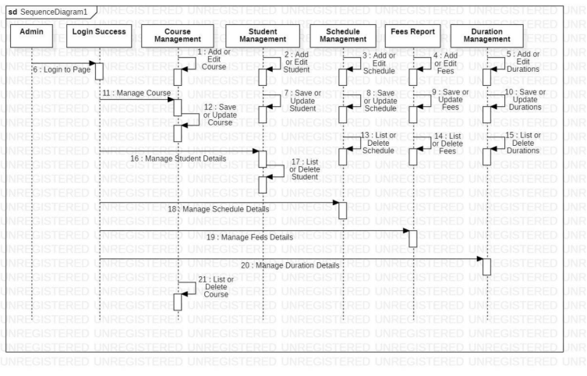

**Assignment-3**

**AIM:**

**E-bidding:** This project is aimed at developing a web-based E-bidding Management Tool, which is to provide a platform for buyers and sellers to conduct online auctions efficiently and to offer a user-friendly interface, ensure secure transactions, and create a fair and transparent marketplace.

**User Stories**

* As a seller, I want to list my products for auction, set reserve prices, receive bids, and manage my listings efficiently.
* Sellers should be able to create product listings, product descriptions, and initial bid prices.
* Sellers can specify a reserve price to ensure that the product is not sold below a certain threshold.
* Sellers should be able to start and stop auctions for their listed products.
* Sellers should have the option to extend the auction duration if desired.
* As a buyer, I want to browse available products, place bids, and track the status of my bids.
* Buyers should be able to browse and search for products listed in various categories.
* Buyers should be able to place bids on products they are interested in.
* The system should update the current highest bid in real-time for each product.
* Buyers should have access to a dashboard where they can view all products, they have placed bids on.
* The dashboard should display bid status, such as winning or losing.

**Functional Requirements**

* User Authentication and Authorization:

The system should provide user registration, login, and password recovery functionalities.

* Role Management:

User roles (seller and buyer) should be asked at sign up time.

* User Profile Management:

Users should be able to update their profiles, including contact information.

* Course Materials:

Instructors should be able to upload and manage course materials, including documents, videos, and links.

* Enrollments:

Students should be able to enroll in courses, and instructors should be able to view and manage course rosters.

* Communication:

Implement messaging and notification features for communication between students and instructors.

* Assignments and Grading:

Instructors should be able to create assignments, and students should submit assignments. Instructors can grade and provide feedback.

* Scheduling:

Allow the scheduling of class sessions, including in-person and virtual meetings, with calendar integration.

* Reporting:

Provide reporting capabilities for administrators to monitor course enrollment, student progress, and system usage.

**Non-Functional Requirements:**

* Security:

User data and transaction information should be securely stored and transmitted. Payment information should be protected.

* Performance:

The system should be responsive and able to handle concurrent users during peak times. Load balancing and caching mechanisms should be in place to optimize performance.

* Reliability:

Ensure system uptime and availability with minimal downtime for maintenance.

* Scalability:

The system should be scalable to accommodate a growing number of users and listings.

* Usability:

The user interface should be intuitive and user-friendly for both sellers and buyers.

* Payment Processing:

The system should integrate with a secure payment gateway to process payments for sold products.

**Use Case-diagram:**



**Activity Diagram:**



**Class Diagram:**



**Sequence diagram:**

